

King Saud University

College of Computer and Information Sciences

Computer Science Department

|  |  |  |
| --- | --- | --- |
| CSC380 | First Semester |  |
| Fundamentals Of Database Systems |  |
| 1438-1439 |  |
|  |  |
|  |  |  |

***Library Project***

**Library Management System**

|  |  |  |
| --- | --- | --- |
|  | **Team4#** | |
|  |  |  |
| **Student Name** |  | **ID** |
|  |  |  |
| **Taghreed M. Alhussan** |  | 438201646 |
|  |  |  |
| **Yara Alfagih** |  | 438200474 |
|  |  |  |
| **Haifa Alrayes** |  | 438200619 |
|  |  |  |
| **Haya AlSulaiman** |  | 438200451 |
|  |  |  |

1

**1. Overview**

*Libraries have always had a broad educational mission it has a huge impact on society it helps people to get information easily, and provide a quiet environment for studying or reading. Library contains many sections each section contains many books ,where people can benefit from books either by borrowing it or reading it in the library. We are building a data base for a library to help them keep track of their employees , barrows, and books.*

1. **Requirement Specification**

*-Library keeps track of employee name, ID, address, and phone. The library must have only one manager. Employee either manages section or sorts books.*

*-Each book must have author name, book title, book edition, ISBN, and number of copies. Each book must sort by only one employee. Each book must publish by publisher.*

*-Library keeps track of publisher name, and unique commerce number. Each publisher must publish at least one book.*

* *Borrower Borrows (at least one book, at most 3 books). Library keeps track of Borrower name, ID, phone, and insurance. The borrowing has start date, end date.*

*-Section have many books and manage by one employee at most, section identified by unique name and section number.*

2

1. **Entity Relationship Diagram**

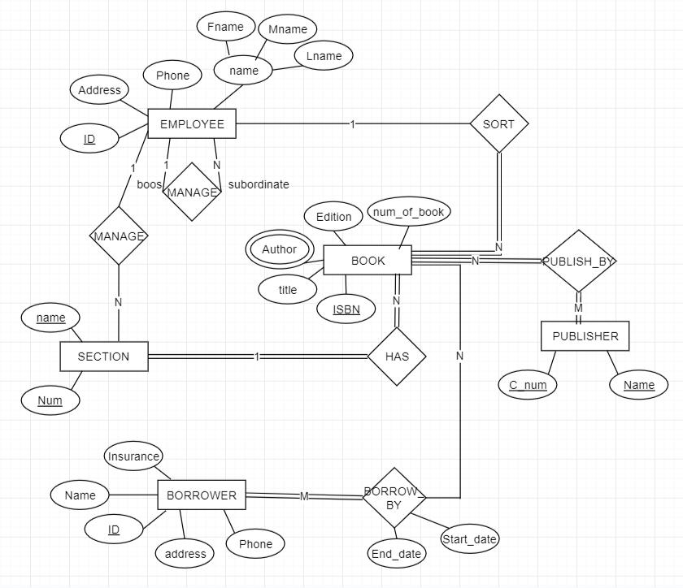



1



3

**4. Realitional Schema**

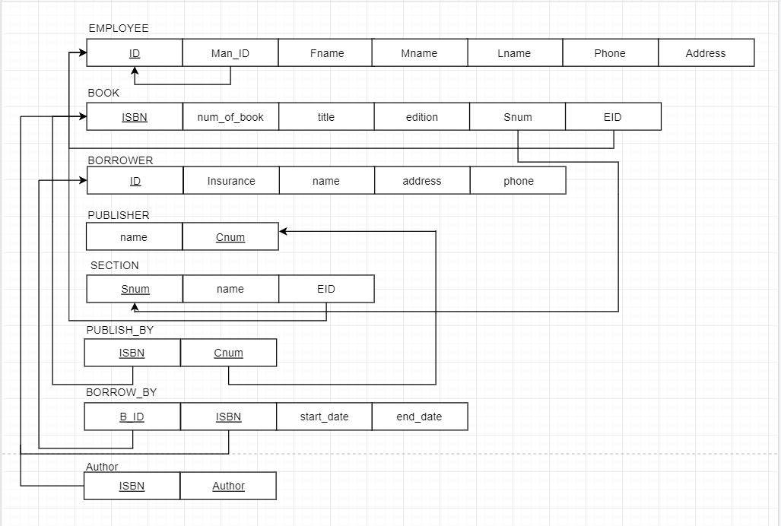



1. **System users**

**ADMINISTRATOR VIEW**

Employees Information

(Administrator who manages the database and can view employees information and modify on data)

|  |  |  |  |  |  |
| --- | --- | --- | --- | --- | --- |
| First name | Last name | ID | Section name | Phone number | Address |
| Fahad | Al-jam | 1234567891 | Computer science | 054436899 | ALSAHAFAH-7A |

***Operations:***

* *Retrieve* each Employee information by ID : **First name** , **Last name ,** the name of the section they manage.
* *Update* **Address** .
* *Insert* each new Employee information: Employee ID**,** First name, Last name, Phone number, and address.

**LIBRARIAN VIEW**

Borrowing system

(librarian is a person who works in a library, has access to Borrowing system he can and modify the data after return or borrow)

|  |  |  |  |  |  |
| --- | --- | --- | --- | --- | --- |
| First name | Book title | Start date | End date | ID | Insurance |
| Rema | DATABASE | 2019-8-19 | 2019-8-30 | 0000000113 | AB-123 |

***Operations:***

* *Retrieve* each Borrower information by End Date: First name , Book title **,** Insurance.
* *Return Book (by deleting borrower from table borrow_by )* .
* *Borrow book (Insert new* Borrower to table borrow_by).
* *Update num_of_book for each book (**after return or borrow ).*

*This section covers the views for all user groups of the system and their operations (phase#3)*

1. **Implementation**

*Connection part*

1. **Test and Run**

*This section defines the test cases applied in your code and sample run from the project.*

**7. Difficulties**

*Problems that you faced and how you solved it.*

4